`

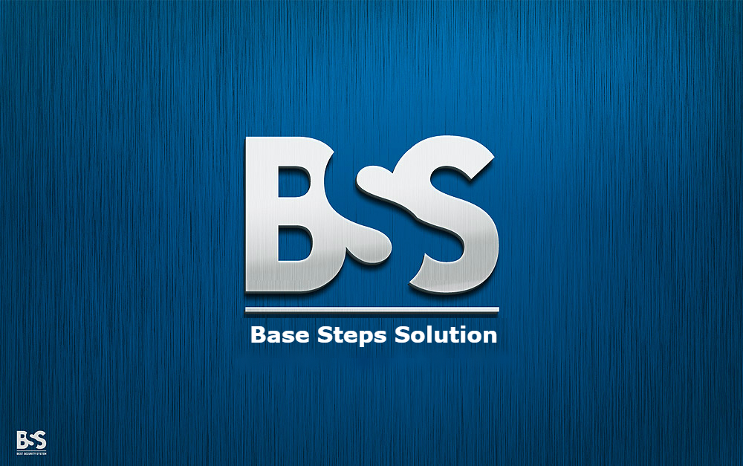

Meeting Minutes

Van Lang Admissions

# Revision Table

|  |  |  |  |
| --- | --- | --- | --- |
| Author | Date | Reason for changes | Version |
| Khoi Nguyen | 8/11/2016 | Initial Document | 1.0 |

Table of Contents

Revision Table 1

1 Purpose of meeting: 3

2 Participants in meeting 3

3 Content 3

4 References 4

5 Note 4

6 To Do Tasks 4

7 Next meeting 4

|  |  |  |  |  |  |
| --- | --- | --- | --- | --- | --- |
| **Writer:** | Nguyễn Anh Khởi | **Location:** | Redsun Company | | |
| **Date:** | **8/11/2016** | **Start:** | 11h40 | **Finish:** | 12h40 |

|  |
| --- |
| Purpose of meeting: |
| * Review Process * Discuss about incremental process |

|  |  |  |  |
| --- | --- | --- | --- |
| Participants in meeting | | | |
| Name | Role | E-mail | Phone |
| Lê Sĩ Phú | Mentor | lesiphu@vanlanguni.vn | 0986982003 |
| Nguyễn Thái Hiền | Leader | hiennguyenthai93@gmail.com | 0937398353 |
| Trần Xuân Hải | Member | haitran2402@gmail.com | 01662542331 |
| Nguyễn Anh Khởi | Member | nguyenanhkhoicntt@gmai.com | 0933408603 |
| Đoàn Anh Minh | Member | minhdoan414@gmail.com | 01284144641 |
| Nguyễn Hoàng Anh Tài | Member | nguyenhoanganhtai95@gmail.com | 01203244599 |
| Nguyễn Xuân Thái Hiền | Member | bs.gtts44@gmail.com | 0974949241 |

|  |
| --- |
| Content |
| - Review incremental process  + Advantage :  Flexible than water fall model , wrong when compare with agile model  Scrum’s stability isn’t high  + Disadvantage : may be acceptable.  + Compare with Water fall model & Srum model   1. Not all and frequently : wrong. 2. Project cost : wrong 3. Guarantee of success : Where to evaluation based on ? 4. Required expertise : no measure (most companies based on years of experience ) 5. Overlapping phase : don’t understand   14. Risk involment : why low ?  + Discuss about scope of project.  + Discuss about process decision. |

|  |
| --- |
| References |
|  |

|  |
| --- |
| Note |
| - Update document  - Meeting with Customer at 10/11/2016 |

|  |  |  |  |  |
| --- | --- | --- | --- | --- |
| To Do Tasks | | | | |
| **#** | **Task** | **Start date** | **Completion date** | **Status** |
| 1 | Update Project Plan | 8/11/2016 | 10/11/2016 | High |
| 2 | Update Processes | 8/11/2016 | 10/11/2016 | High |
| 3 | Learn software development ( Nodejs , MongoDB , AngilarJS … ) | 8/11/2016 | 10/11/2016 | Medium |
| 4 |  |  |  |  |

|  |  |  |  |
| --- | --- | --- | --- |
| Next meeting | | | |
| **Date: 21/11/2016** | **Content:** | **Time: 10h30** | **Location: 701C** |
| **Writer:** | Nguyễn Anh Khởi | | |

---- *** ----